Advisory Teaching Service

Advice Sheet for Developing Reading Fluency




Fluent reading refers to the ability to read orally with speed, accuracy and proper expression. Strategies that increase fluency have a positive impact on reading and particularly on reading comprehension.

Ensure that the reading age and interest level are appropriate

- In order for pupils to develop reading fluency and confidence, they need to be reading at the right level. This is the level at which frustration is avoided, but there is enough challenge for the children to be learning new skills and making progress.
- The text should allow the child to read with at least 75% accuracy.
- Provide books with predictable vocabulary and clear rhythmic patterns so the child can hear the sound of fluent reading as he or she reads the book aloud.
- Older children need to have a range of books that will have a high interest level and be age appropriate while still enabling independent reading.
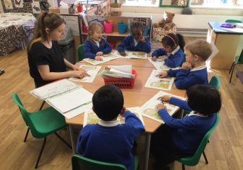
- Children can improve their fluency by re-reading a short book or for older children, re-reading a certain passage from a story. As they become more familiar with the text, they can focus their attention on reading it fluently. Practising the same selection will give them the opportunity to master becoming a fluent reader.

Guided Oral Reading
- Model reading so children understand what you mean when you ask them to use expression or to string words together more smoothly.
- After modelling fluent reading, encourage the pupil to read the same passage aloud giving lots of encouragement and feedback.
- Use audiobooks or e-books which can be read aloud to enable children to hear what fluent reading sounds like.
- Encourage fluency by using ‘choral reading’. This occurs when a group of children read something together, saying the words at the same time. You might read the text out loud by yourself first, so the children can hear how the reading should sound. Then you can read it together, with pupils matching your pace and expression.
- Reading play scripts can be a motivating way to improve fluency. Students can read scripts and rehearse parts in a play to in order to prepare for a performance. The practice of reading and re-reading scripts provides an effective and enjoyable opportunity to improve fluency skills.
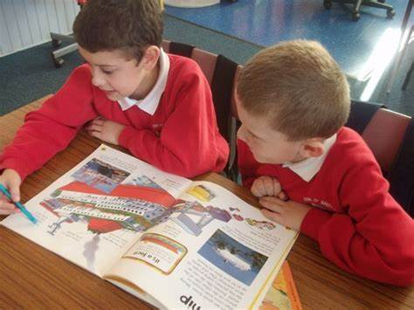
Paired Reading
- The paired reading sessions should be fun and relaxed, and should give the child the chance to practise their reading skills without worrying about making mistakes. A variety of reading material can be used.
- A child reads with an adult or a peer partner, with each partner taking turns reading to the other. Peer partners can be the same age or the process can also work well between children in different year groups.
- A more fluent reader is paired with a less fluent reader in order to model accurate and fluent reading, provide feedback and encourage the less fluent reader.
- Start by reading together at the same pace. If the child is reading too slowly or quickly, encourage them to mirror your pace.
- If a child makes a mistake when reading give them time before offering a prompt and remember to praise their efforts.

Support Fluency by continuing to use a combination of strategies

- Practise oral blending (Letters and Sounds Phase One Aspect 7)
- Develop knowledge of high frequency words
- Develop phonic strategies
- Encourage ability to split words up – look for smaller words and familiar letter patterns
- Look for common beginnings and endings of words
- Practise letter and word tracking activities and encourage use of a line guide
- Cloze procedure
- Speed reading games
- Precision Teaching strategies

Useful Resources
- Rapid Reading
- Floppy Phonics
- Songbird Phonics
- Collins “Big cat”
- Rigby Star
- Reading Rockets
- High interest/low reading age materials such as Phonicbooks, Project X ,Project X Code, Skyway,
- E-books available online from Oxford Owl (these can be accessed for free by parents)
- Audible, where a range of audio books can be downloaded
- Ann Arbor Tracking for High Frequency Words and Letter Tracking
- Provide access to a Scanner Pen/ Reading Pen
- Paired Reading Guide by Gloucestershire Educational Psychology Service

Advisory Teaching Service: April 2020

